**Moving window for time series data:**

For time series data we take a window of time, eg of ECG where for a particular time period we’ve taken a window, now we’ll find feature value within that window.

We can find following type of features in that window.

1. Mean, std deviation in that window
2. Median, MAD in that window
3. Max (which is the highest peak) and min
4. Max – Min or Max/Min
5. Number of local maxima or minima(local peaks in that window)
6. Mean crossing

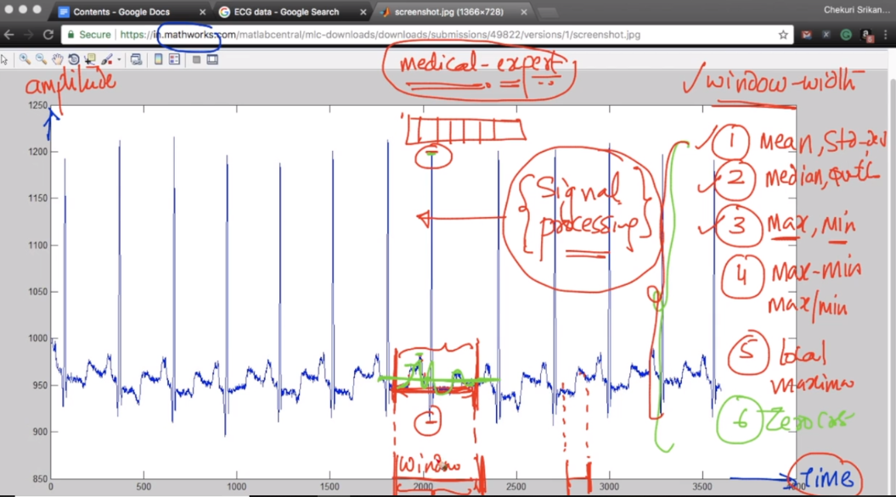

Let’s you are given an ECG and you’ve to find whether a patient can have heart attack in next ten minutes.

So first we take domain expert advice for this problem we ask dr., let’s say he said that check on recent 1 sec, so we create a window on the recent 1 second.

Now again we ask dr. what are the things he looks in report to make decision. Like he says that in recent 1 second patient’s heart beat would increase. So taking this consideration we make a feature as the no. of peak points we obtain, or it can be no of waves crossing some particular value.

So after discussion with domain expert we would make our features.

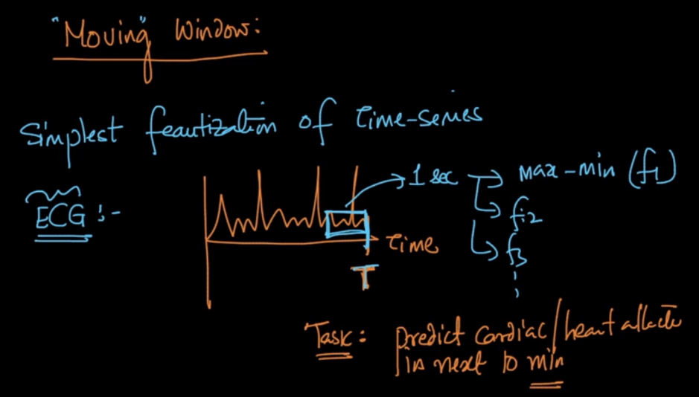

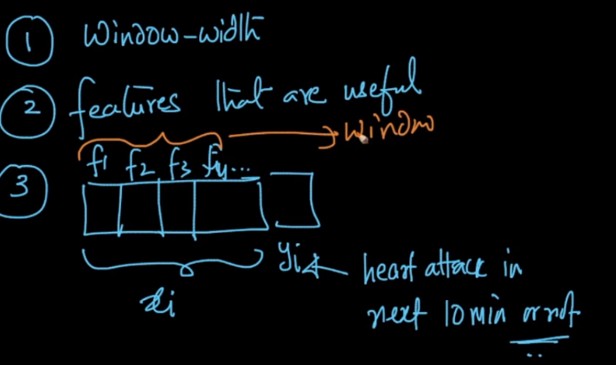

Deeplearning is one thing which automatically find most of the useful features if you have a lot of data, but not always.

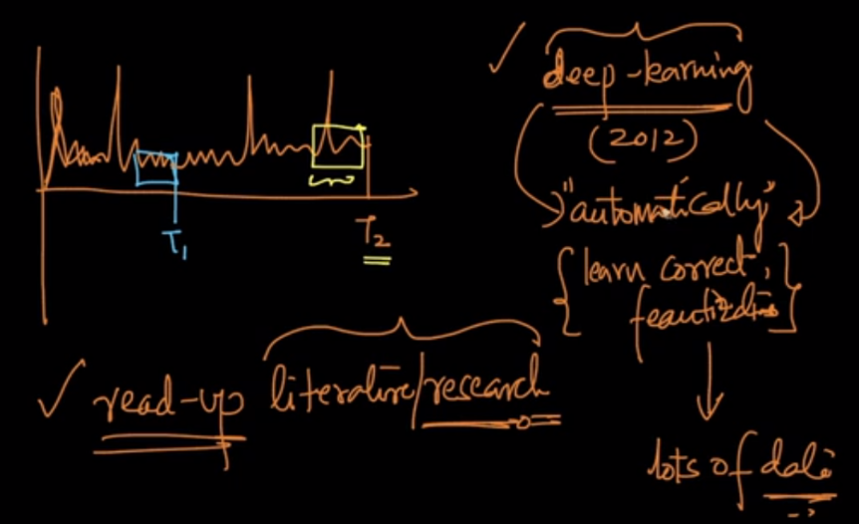

**Comments:**

1. 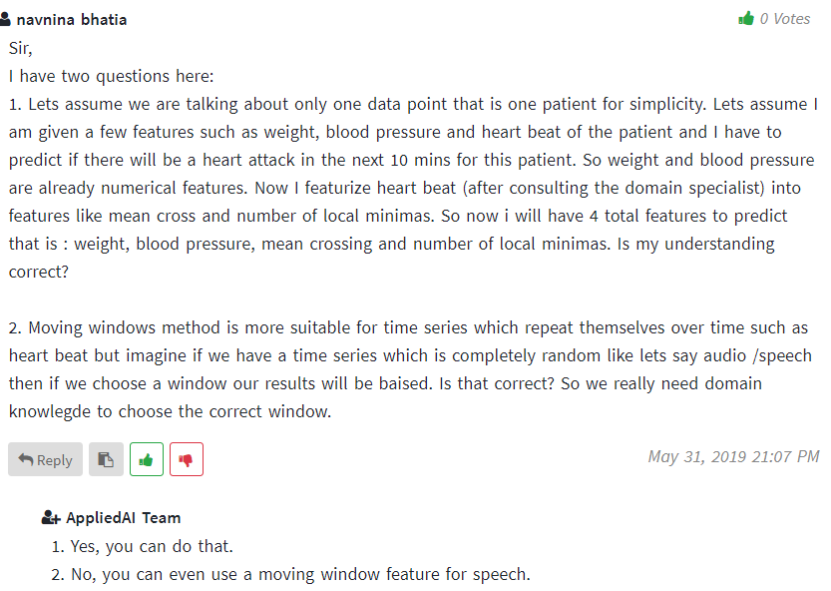

**2 )**

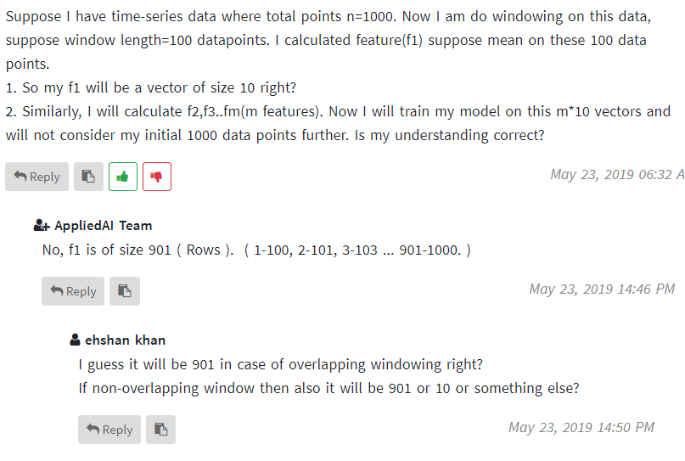

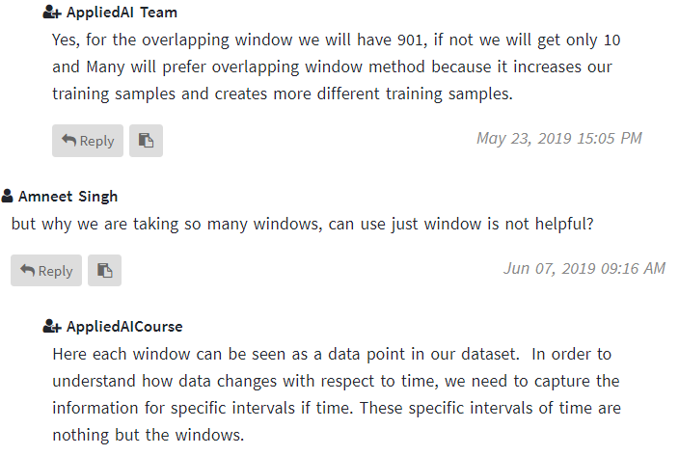

**3 )**

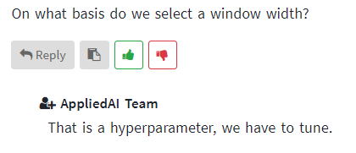

**4 )**

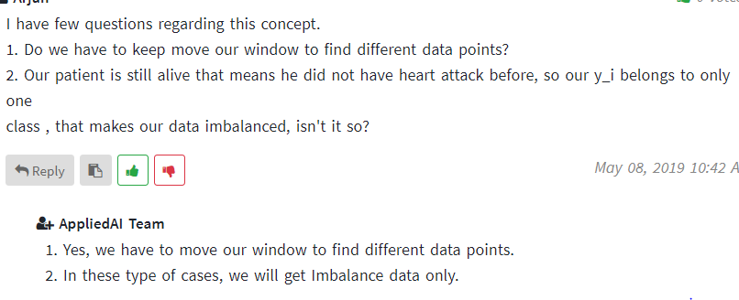

**5 )**

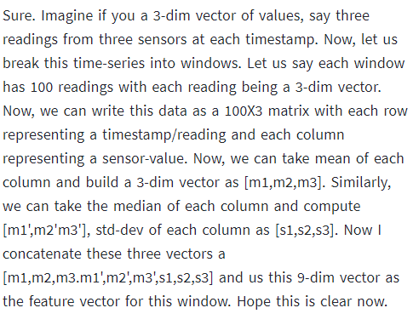

<https://medium.com/making-sense-of-data/time-series-next-value-prediction-using-regression-over-a-rolling-window-228f0acae363>

<https://machinelearningmastery.com/moving-average-smoothing-for-time-series-forecasting-python/>